Employee Management System

## Low Level Design Document for Employee Management System.

**“Employee Management System” Team-3**

## C2312 - Java with Spring Framework Case Study.

|  |  |
| --- | --- |
| **Version** |  |
| **Authorized by** |  |

1

***Low Level Design Document for Employee Management System***

# Table of Contents

Table of Contents ii

Revision History ii

1. Introduction 1
   1. Scope of Document 1
   2. Intended Audience and Reading Suggestions 1
   3. System Overview………………………………………………………………………………..1
   4. References 1
2. System Use Cases 2
3. Detailed System Design………………………………………………………………………4
   1. Design Description of Employee Management System 4
   2. Sequence Diagram 6
   3. Class Diagram 9
   4. Activity Diagram 11

3.5 External Interface Requirements 13

1. Security……………………………………………………………………………………….14

Appendix A: Glossary…………………………………………………………………………..15

# Revision History

|  |  |  |  |
| --- | --- | --- | --- |
| **Name** | **Date** | **Reason For Changes** | **Version** |
| Team - 3 | 1-02-2023 | Extra module need to be added to the project. | 1.0 |
| Team - 3 | 3-02-2023 | Created a module for providing feedback | 2.0 |
|  |  |  |  |
|  |  |  |  |
|  |  |  |  |

## Introduction

### Scope of the document.

Low-level design provides detailed description of every module of the project “Employee Management System”. It describes every module in detail by incorporating the logic behind every component in the system. It delves deep into every specification of every system, providing a micro-level design.

### Intended Audience and Reading Suggestions

Document is primarily intended for members of a specific company and its system admin to carry out the work efficiently.

### System Overview.

Employee management is the process of managing and directing the activities and performance of employees within an organization. This includes tasks such as providing feedback and viewing details . There are a variety of tools and techniques that can be used to improve employee performance, including setting clear expectations, providing regular feedback, and offering opportunities for growth and development.

### References

* Project Proposal Document.
* System Specification for Employee Management System.
* System Architecture and High Level Design for Employee Management System.

# System Use Cases

A Use Case Model describes the proposed functionality of a new system. A Use Case represents a discrete unit of interaction between a user (human or machine) and the system. This interaction is a single unit of meaningful work, such as Create Account or View Account Details.

### Use Case Diagram for Employee Management System.

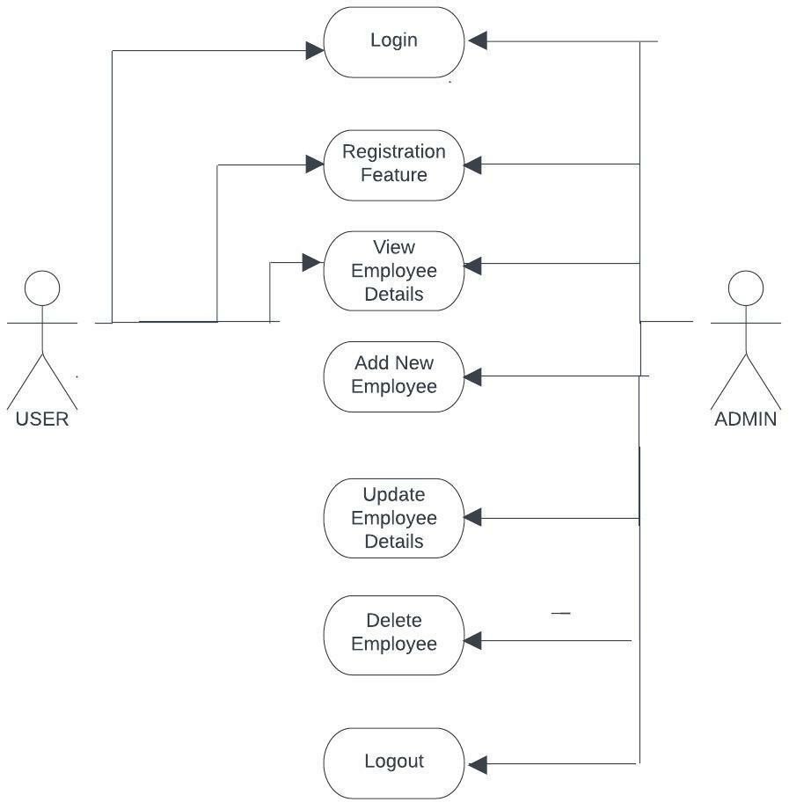

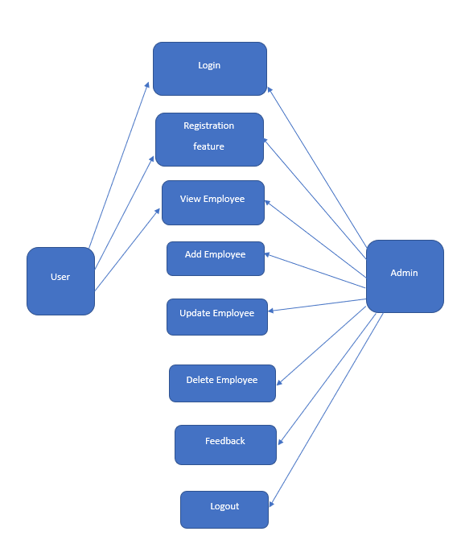

USE CASE DIAGRAM 2.0

**Actor: Admin** - Representing the person who has access to the system and can perform actions such as adding, deleting, and updating employees.

#### Use cases for admin:

1. **Add Employee:** Admin can add new employees to the system by providing their personal and professional details.
2. **Delete Employee:** Admin can delete employees from the system who are no longer working for the company.
3. **Update Employee:** Admin can update the details of existing employees in the system.
4. **View Employee:** Admin can view the details of employees in the system.

#### Relationships:

The Admin actor is associated with all of the use cases, indicating that they are the ones who can perform these actions.

The use cases are connected to each other, indicating that they are all related to the employee management system.

**Actor: User** - Representing the person who can log in through his credentials and register if he is a new user.

#### Use cases for user:

i**.Log in:** User can login by entering their required user credentials like user name and password. ii**.Register:** If user is new he can register by providing his personal and professional details required.

**iii.Provide Feedback**: The employee can give the feedback.

# Detailed System Design

.

### Design Description for Employee Management System.

The design of the employee management system is focused on providing a user-friendly and intuitive interface for both administrators and employees. The system is web-based and can be accessed from any device with internet access.

The system has a login page for administrators, where they can enter their unique username and password to access the system. Once logged in, administrators are presented with a dashboard displaying an overview of the employee data. Administrators can navigate through different sections of the system using a top navigation menu, which includes options such as "Add Employee," "Update Employee," "Delete Employee," and "Sort Employee."

The system also provides a registration page for employees to create an account and login to the system. This page requires employees to enter their personal information, such as name, address, and contact details. Once logged in, employees can view their personal information.

The system also includes a search feature that allows administrators and employees to quickly find specific employees by name or job title. Additionally, the system is designed to be flexible, so that administrators can customize it to fit the specific needs of their organization.

Overall, the design of the employee management system is intended to provide a comprehensive and efficient way for organizations to manage and track employee information, while also providing employees with easy access to their personal details.

**Admin Login:** The administrator of the employee management system can log in to the system using a unique username and password.

**Add Employee:** Once logged in, the administrator can add new employees to the system by entering their personal information, such as name, address, contact details, and job title.

**Update Employee:** The administrator can also update existing employee information, such as their job title or salary, by searching for the employee and making the necessary changes.

**Delete Employee:** The administrator can delete an employee from the system by searching for the employee and selecting the option to delete.

**Sort Employee:** The administrator can sort employee information by various criteria, such as name, job title, or salary, to easily find and view specific employees.

**User Registration:** Users, such as employees, can register for an account on the employee management system by providing their personal information, such as name, address, and contact details.

**User Login:** Once registered, users can log in to the system using their unique username and password to view their personal information and other relevant details.

**View Details:** Users can view their personal information, such as their job title, salary, and performance evaluations, as well as their schedules, vacation time, and benefits.

### Sequence Diagram.

A sequence diagram is a type of UML (Unified Modeling Language) diagram that shows the interaction between objects or components in a system. In the context of an employee management system, a sequence diagram can be used to represent the interactions between the user, the system, and the database.

The sequence diagram for the employee management system would typically start with the user opening the system in their web browser. The user would then be prompted to log in or register if they are a new user.

If the user chooses to log in, the system would check the user's credentials against the database to determine if the user’s credentials are valid then allows user to view details. I

If administrator is using the system would show the administrator dashboard, which would display an overview of employee information.

If the user is an employee, the system would show the employee's personal information and details. The employee can view their information, but cannot make changes to it.

If the user chooses to register, the system would show a registration page where the user would enter their personal information, such as name, address, and contact details. Once the user has entered their information, the system would add the information to the database and log the user into the system.

In the sequence diagram, these interactions between the user, the system, and the database would be represented by arrows, showing the flow of control and the exchange of data.

For example, the user might initiate a request to view an employee's information, which the system would then retrieve from the database and display on the screen.

Overall, a sequence diagram is a useful tool for visualizing the interactions between different components in a system, and can help to clarify the design of the employee management system and identify any potential issues.

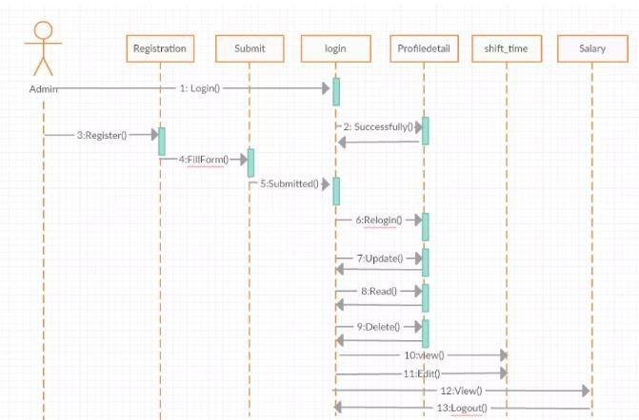

Sequence Diagram for EMS Admin.

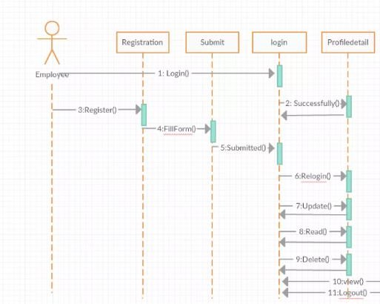

Sequence Diagram for EMS Employee.

**Login:** The user opens the employee management system and is prompted to log in. If the user is an administrator, they enter their username and password. If the user is an employee, they either enter their login credentials if they have already registered, or they click on a link to register.

**Registration:** If the user is an employee who needs to register, they enter their personal information, such as name, address, and contact details, and create a username and password.

**Dashboard:** Once logged in, the user is taken to their dashboard. Administrators see a summary of employee information, while employees see their personal information and details.

**View Employee Information:** Administrators can view detailed information about employees by clicking on the "View Employee" option in the navigation menu. They can also add, update, or delete employee information.

**Search:** administrators and employees can search for specific employees by name or job title using the search feature.

**Logout:** When the user is done using the employee management system, they click on the "Logout" option in the navigation menu to log out of the system.

### Class Diagram.

A class diagram is a type of UML (Unified Modeling Language) diagram that provides a graphical representation of the classes and objects in a system, and the relationships between them.

For the employee management system, the class diagram might include the following classes:

**User:** This class represents the users of the system, including administrators and employees. It might include attributes such as username, password, and name.

**Employee:** This class represents the employees in the system. It might include attributes such as employee ID, job title, salary, and performance evaluations.

**Administrator:** This class represents the administrators of the system. It might include attributes such as administrative privileges, and methods for adding, updating, and deleting employee information.

**System:** This class represents the employee management system as a whole. It might include methods for logging in and registering users, as well as for managing employee information.

**Database**: This class represents the database used to store employee information. It might include methods for retrieving and storing employee data, as well as for searching for specific employees.

The User class might have a relationship with the Employee class, indicating that employees are a type of user. The Administrator class might have a relationship with the System class, indicating that administrators have the ability to access and manage the employee management system.

Overall, a class diagram provides a useful overview of the structure of a system and the relationships between its components, and can help to clarify the design of the employee management system.

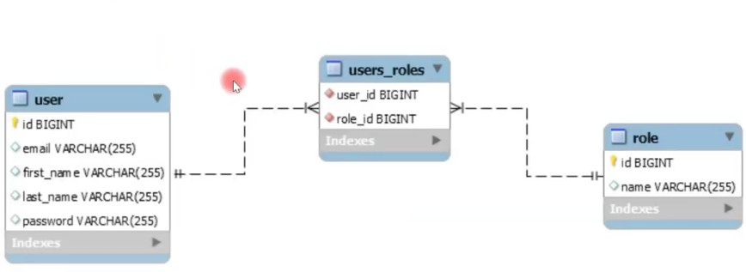

#### Class Diagram for EMS

**Description:**

|  |  |
| --- | --- |
| **Component Name** | **Description** |
|  |  |

**3.4 Activity Diagram for EMS.**

An activity diagram is a type of UML (Unified Modeling Language) diagram that provides a graphical representation of the flow of activities in a system. It is used to model the flow of control in a business process or software system, and to identify the relationships between activities and the conditions under which they are performed.

In the context of the employee management system, an activity diagram could be used to model the steps involved in performing common tasks, such as logging in, viewing employee information, and updating employee information.

The activity diagram consists of a series of shapes that represent activities, along with arrows that show the flow of control from one activity to another. It may also include decision points, where the flow of control is determined by a condition or decision, and loop points, where the flow of control is repeated until a certain condition is met.

The activity diagram for logging in includes the following steps:

* The user enters their username and password on the login screen.
* The system checks the entered credentials against the database to verify that the user is registered.
* If the user is registered, they are granted access to the system and directed to their dashboard.
* If the user is not registered, an error message is displayed and they are prompted to try again or register.

Similarly, the activity diagram for updating employee information includes the following steps:

* The administrator selects the employee to update.
* The administrator updates the employee information, such as job title or salary.
* The system saves the updated information to the database.
* The administrator is notified that the update was successful.

Activity diagrams are a useful tool for modeling the flow of control in a system and for identifying potential areas for improvement or optimization. By visualizing the steps involved in performing common tasks, they can help to clarify the design of the employee management system and ensure that it meets the needs of its users.

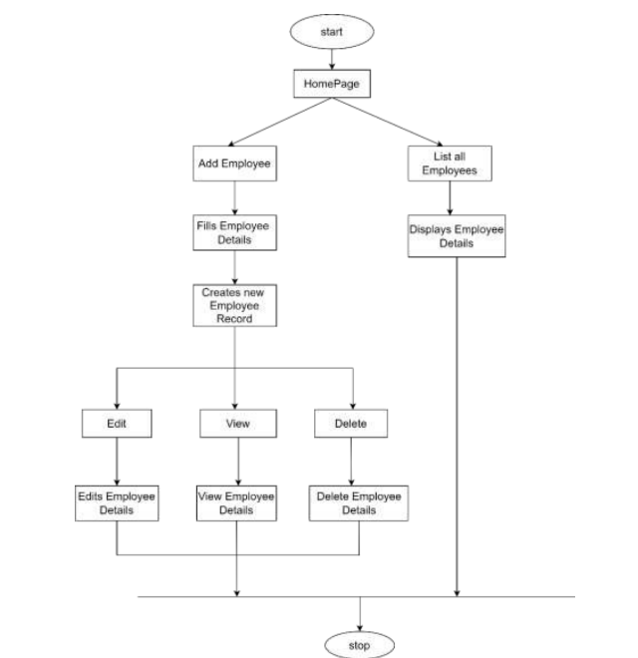

**Activity Diagram for EMS.**

### 3.5 External Interface Requirements.

The interface requirements for the employee management system would outline the key features and functionality that the user interface should provide in order to meet the needs of the users, including administrators and employees.

### User Interfaces.

The user interface for the software shall be compatible to any browser such as Internet Explorer, Mozilla or Netscape Navigator by which user can access to the system.

The user interface shall be implemented using any tool or software package like Java Applet, MS Front Page, EJB etc.

### Hardware Interface

Since the application must run over the internet, all the hardware shall require to connect internet will be hardware interface for the system.

As for e.g. Modem, WAN – LAN, Ethernet Cross-Cable.

### Software Interface

The management system shall communicate with the Configurator to identify all the employees present.

### Communications Interface

The Employee Management system shall use the HTTP protocol for communication over the internet and for intranet communication will be through TCP or IP protocol suite.

# Appendix A: Glossary

* EMS - Employee Management System.
* GUI - Graphical User Interface

### Description:

|  |  |
| --- | --- |
| **Component Name** | **Description** |
|  |  |